NEO4J: SOCIAL NETWORK ANALYSIS

1. Objective
The objective of this exercise is to understand the concepts of graph databases using Neo4j. The exercise focuses on creating and managing nodes and relationships, performing graph traversal, analyzing social network patterns, and developing recommendation-based queries.
The main objectives are:
- To create and manage graph data using Neo4j.
- To understand nodes, labels, and relationships.
- To perform data retrieval using Cypher queries.
- To analyze social network connections.
- To find shortest paths between users.
- To identify influential users and recommendation patterns.
- To understand the advantages of graph databases for connected data.

2. Procedure

Step 1: Connect to Neo4j
- Open the Neo4j Browser interface.
- Connect to the Neo4j database using the provided credentials.
- Clear previous graph data if required.
- Prepare the environment for creating a new social network graph.

Step 2: Create Graph Data
- User nodes were created with attributes such as:
  - User ID
  - Name
  - Age
  - City
  - Interests
- Relationships were created between users using the FOLLOWS relationship type.
- Relationship properties such as:
  - Follow date
  - Trust score
- were added to represent the strength and duration of connections.
- The created graph represents a social network where users interact through follow relationships.

Step 3: Perform Basic Queries
Basic graph queries were performed to retrieve information from the social network.
The following analyses were performed:
- Display all users in the network.
- Retrieve individual user profiles.
- Find users followed by a particular user.
- Identify followers of a specific user.
- Search users based on location.
- Find users having common interests such as technology.
The results helped understand how information can be retrieved efficiently from connected data.

Step 4: Perform Graph Traversals
Graph traversal operations were performed to explore relationships between users.
The following operations were analyzed:
- Finding followers of followers.
- Generating friend recommendations.
- Identifying mutual connections.
- Finding the shortest path between users.
- Measuring network distance between users.
- Discovering users with common interests and similar characteristics.
Graph traversal demonstrated how Neo4j can efficiently navigate complex relationships.

Step 5: Perform Advanced Analytics
Advanced social network analysis was performed to understand user behavior and network structure.
The following analytics were performed:
- Identifying the most followed users.
- Finding the most active users.
- Detecting connected relationship patterns.
- Generating recommendations based on common interests.
- Analyzing network density based on cities.
- Identifying strongest trust relationships.
- Calculating user influence scores.
These analyses help understand popularity, influence, and community structure in social networks.

Step 6: Perform Data Modification
Data modification operations were performed to understand graph updates.
The following operations were carried out:
- Added a new user to the network.
- Created new relationships between users.
- Updated user information.
- Added new interests to users.
- Deleted relationships.
- Removed users along with their connected relationships.
This demonstrated how Neo4j supports dynamic changes in graph data.

Step 7: Graph Visualization
The created social network was visualized using Neo4j Browser.
The following visualizations were generated:
- Complete social network graph.
- Alice's two-level connection network.
- NYC user network.
- Strong trust relationship network.
Visualization helped understand user connections and relationship patterns.

3. Results and Analysis
- A complete social network graph was successfully created.
- Users and their relationships were represented effectively using graph structures.
- Graph traversal provided efficient methods for finding connections and recommendations.
- The shortest path algorithm helped identify connection distance between users.
- Advanced analytics identified influential users and important relationships.
- Neo4j demonstrated strong capabilities for handling highly connected data.

4. Screenshots

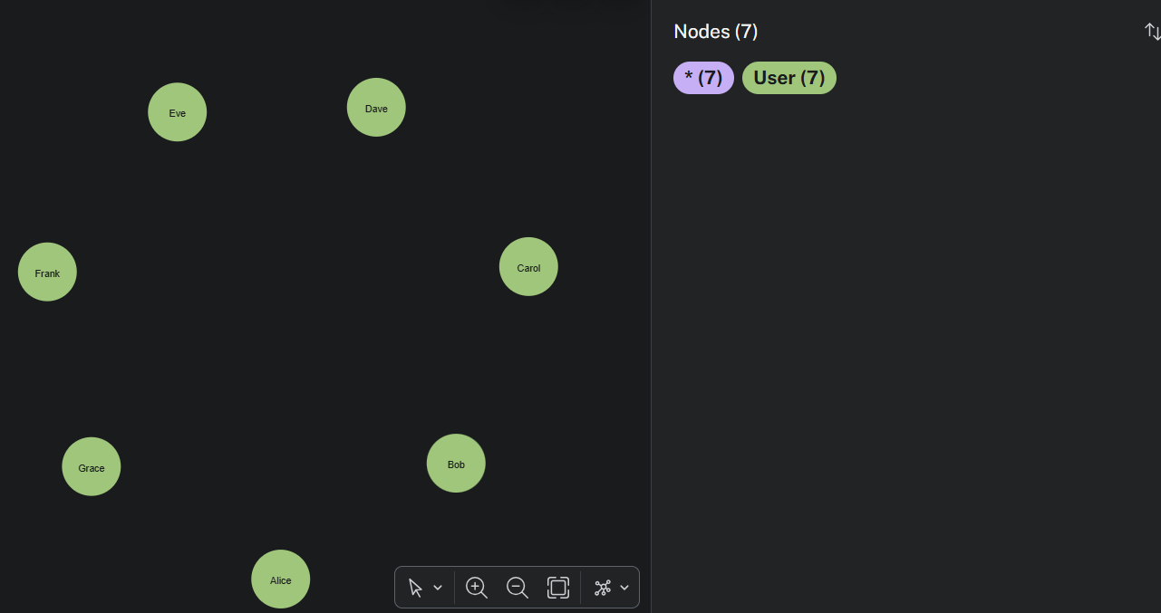
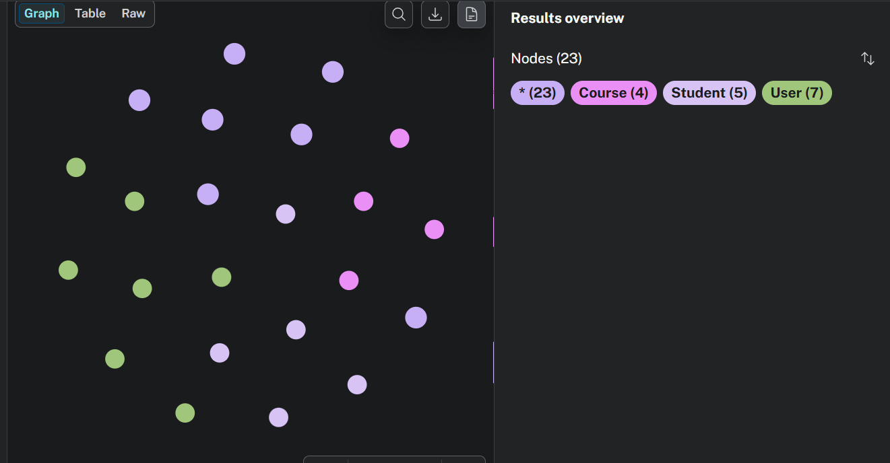
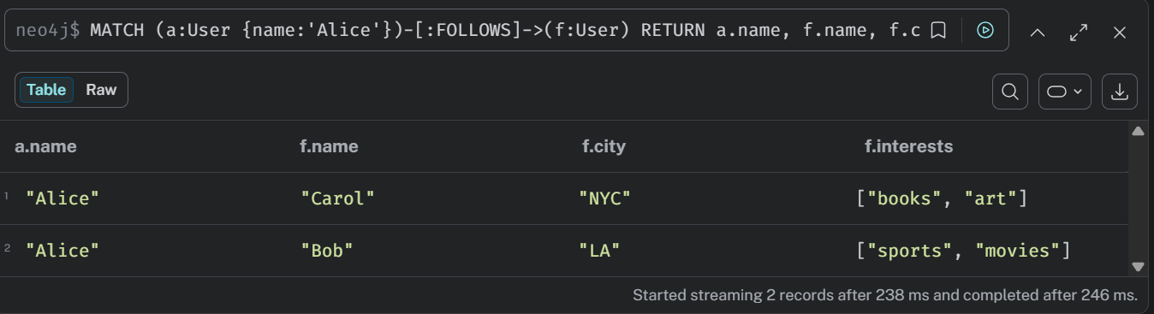
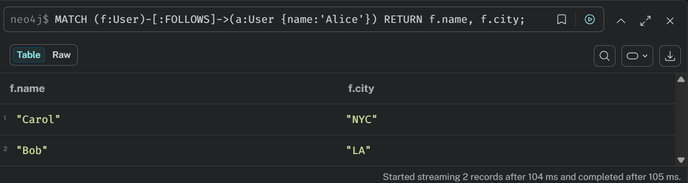
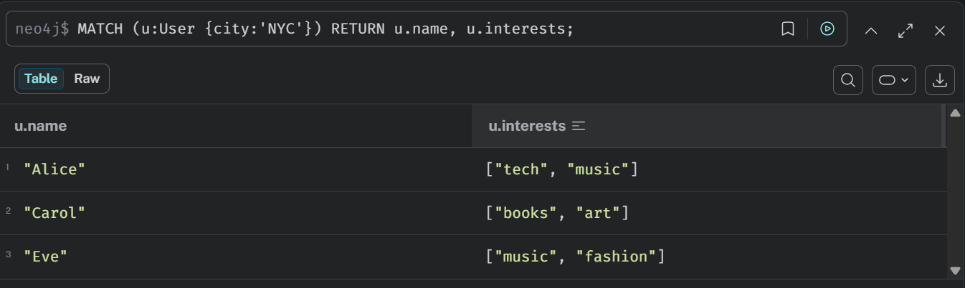
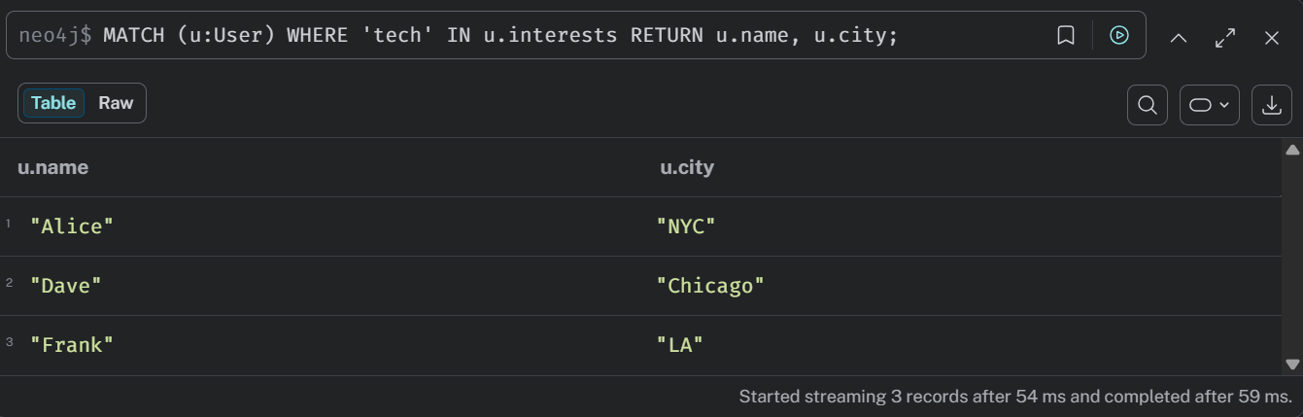
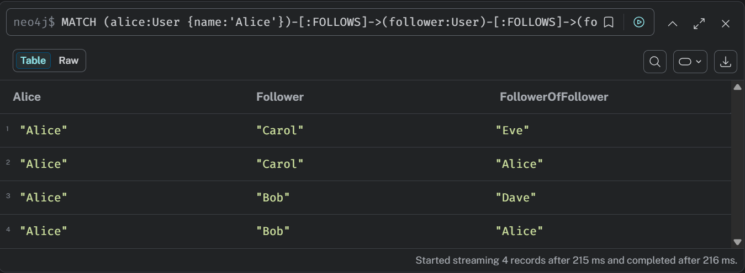
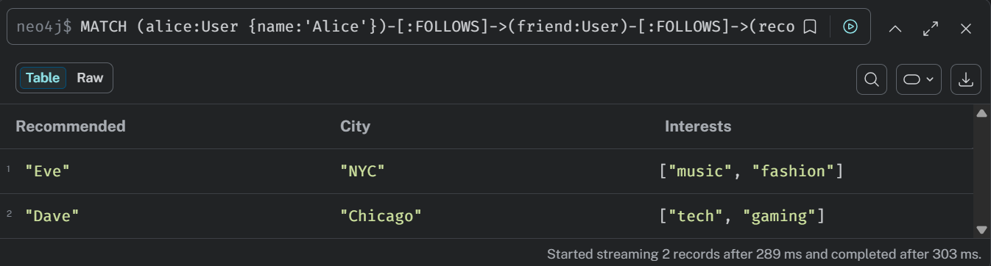
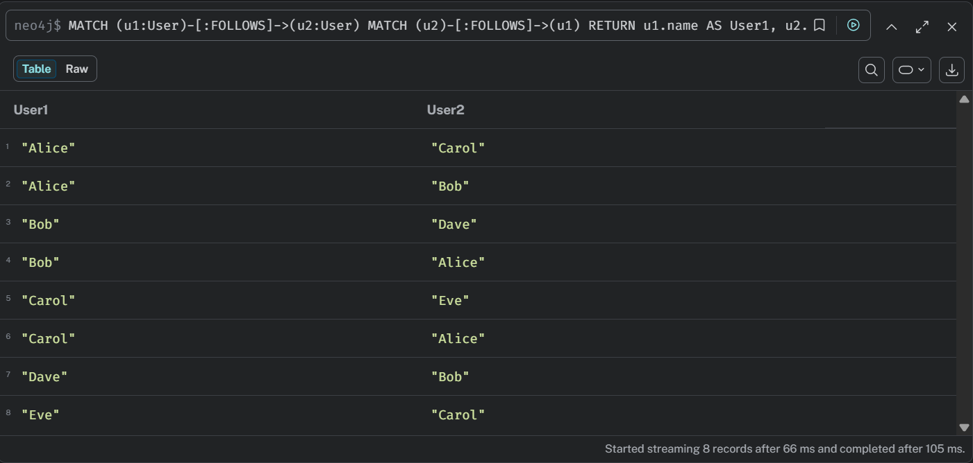
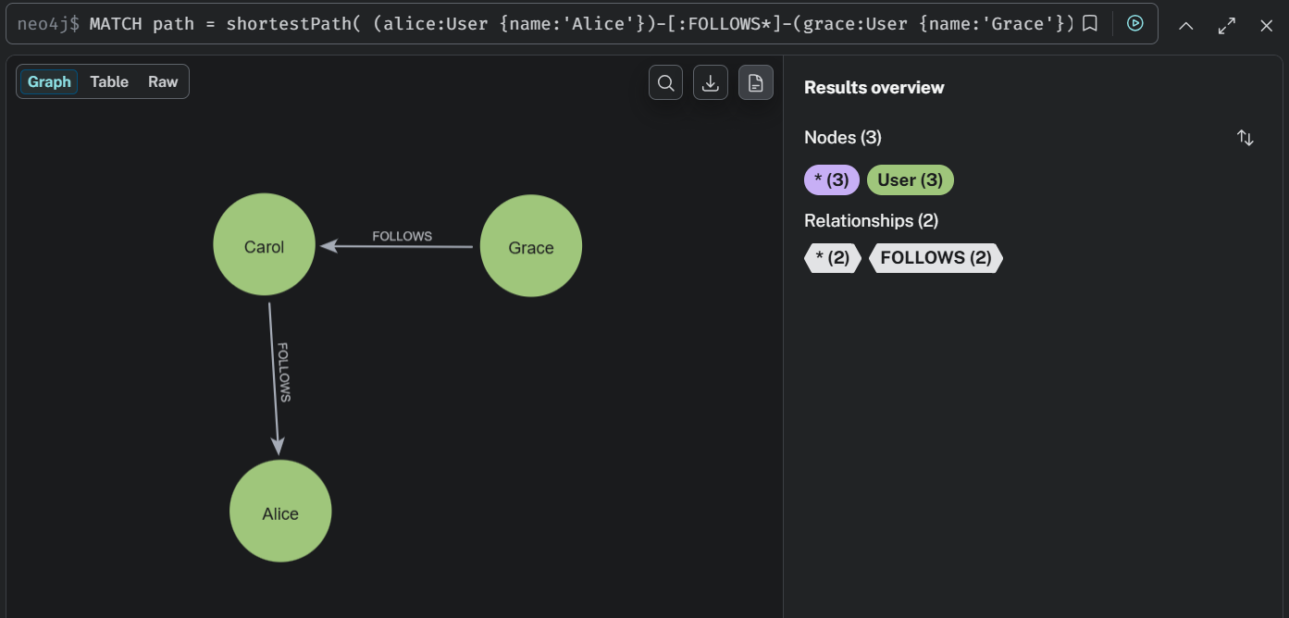
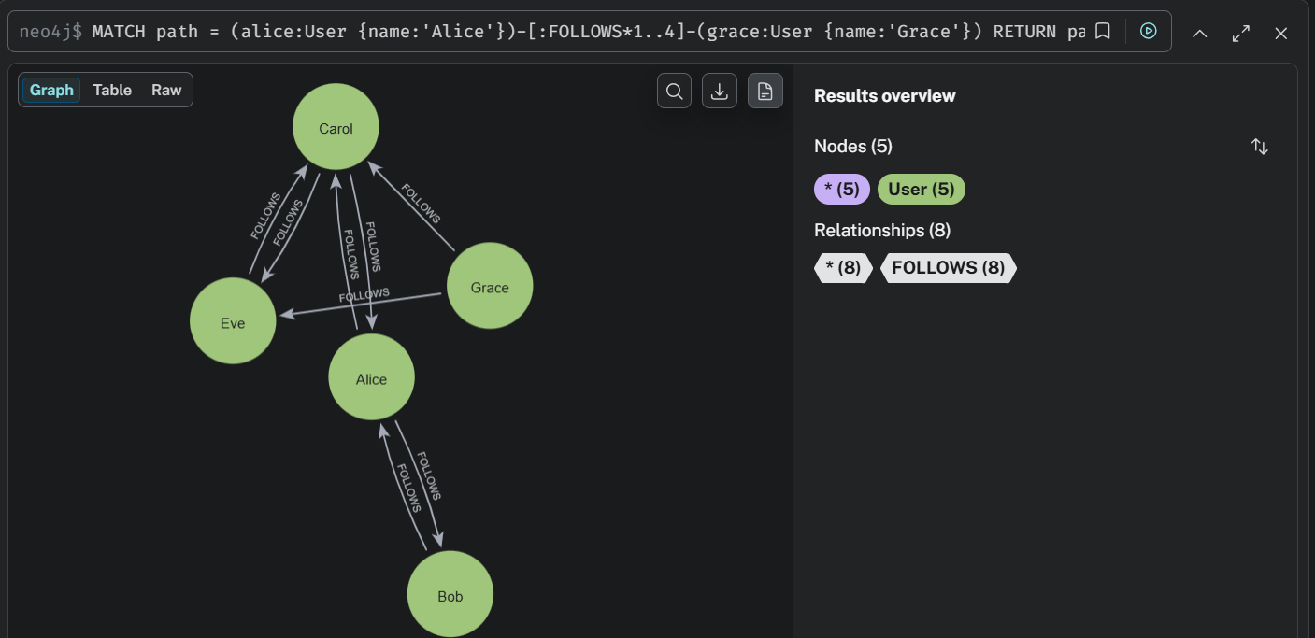
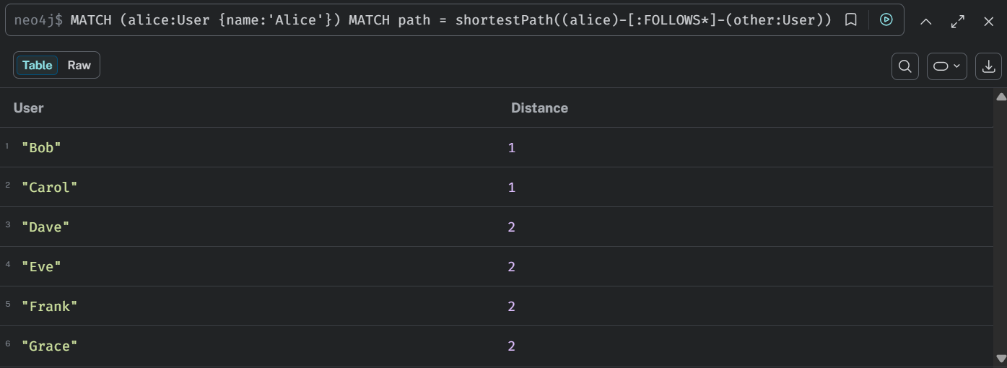
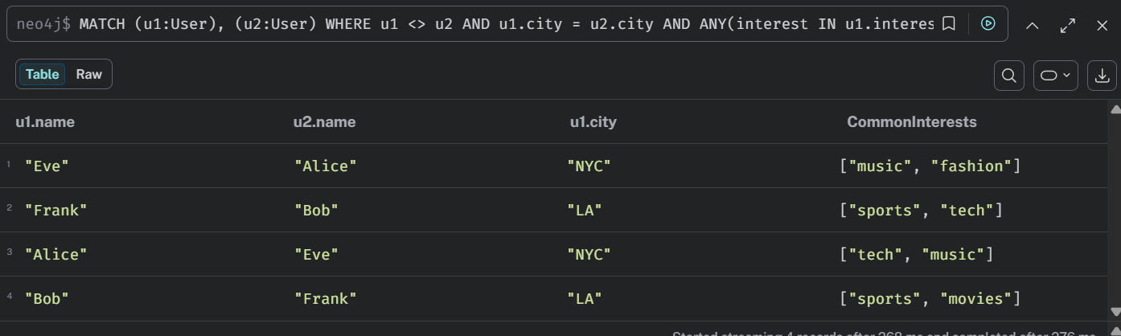
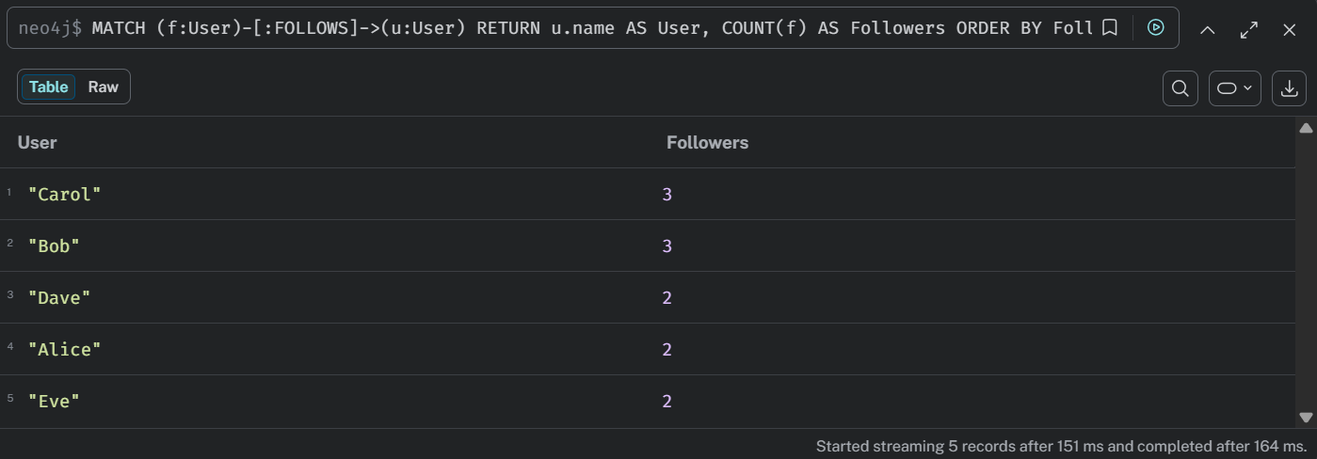
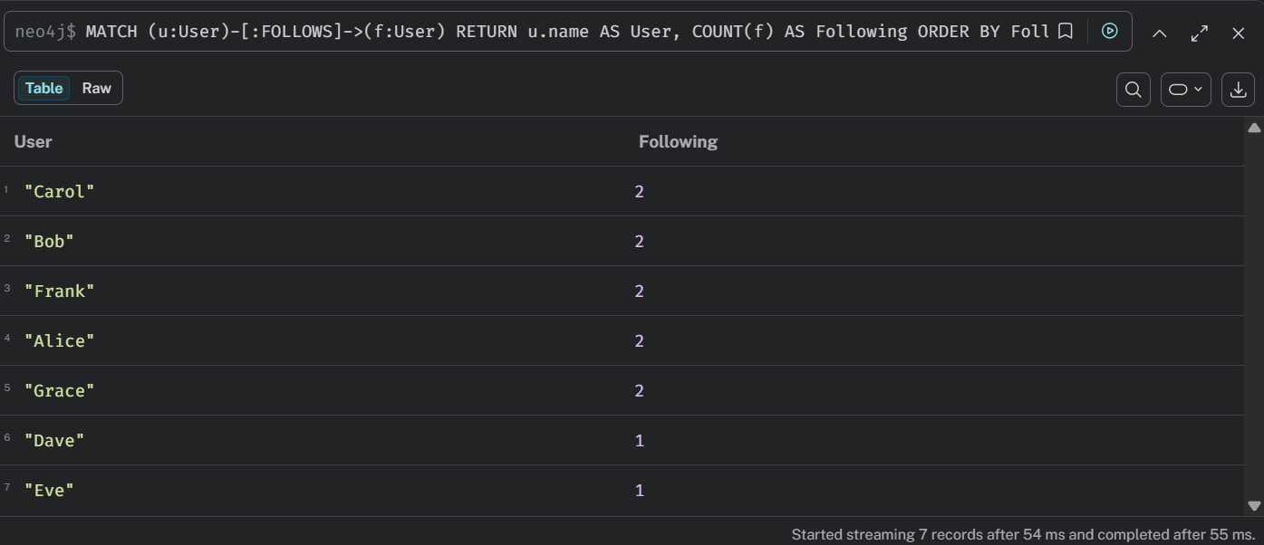
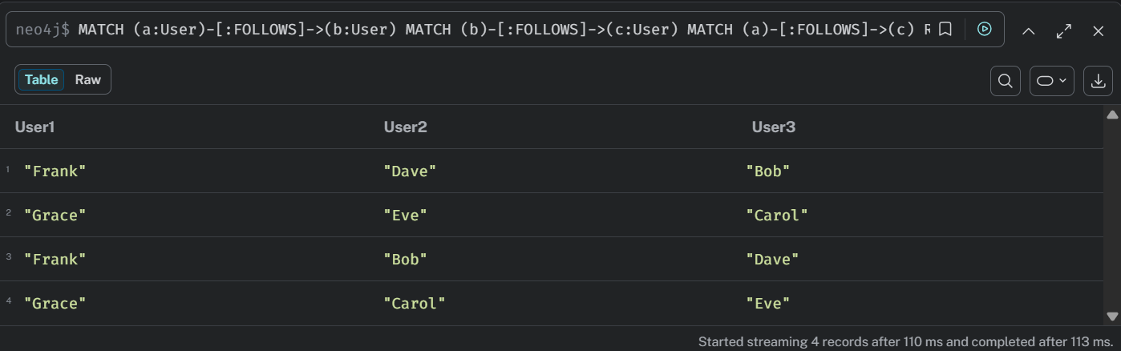
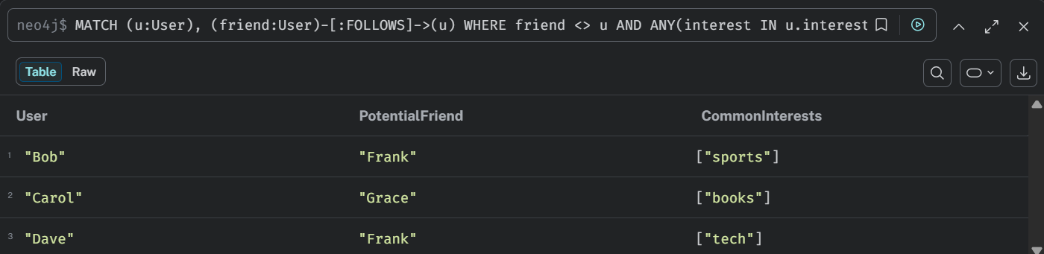
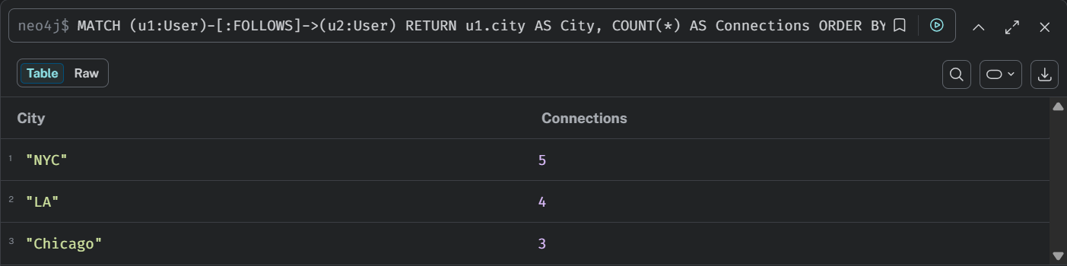
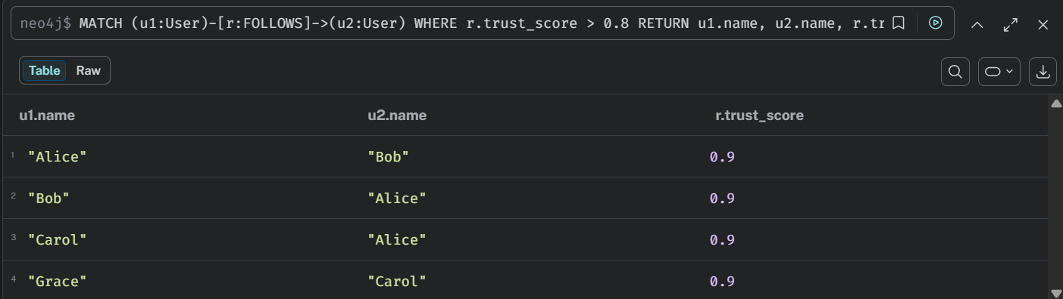
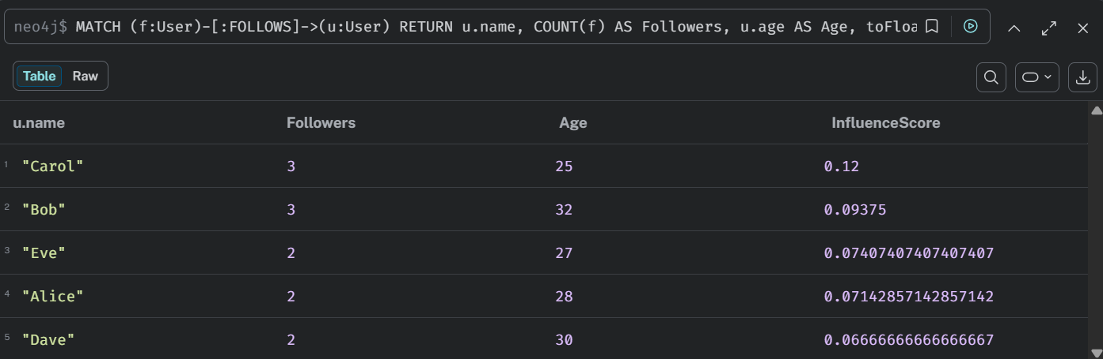
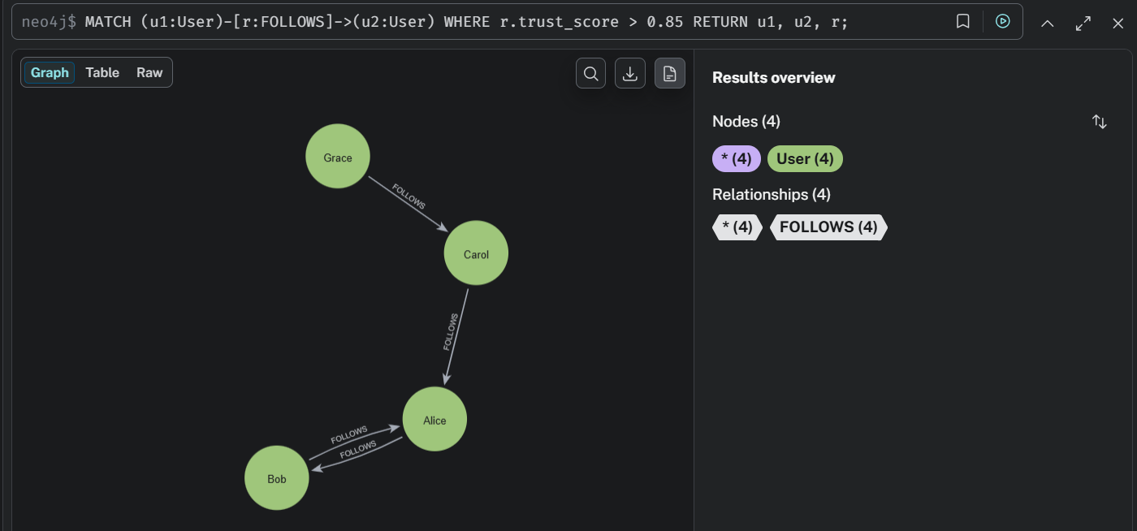

5. Conclusion
This exercise provided practical knowledge of graph database concepts using Neo4j.
The implementation demonstrated how social networks can be modeled using nodes and relationships. Neo4j efficiently handled graph traversal, relationship analysis, recommendation generation, and shortest path calculations.
Graph databases are highly suitable for applications such as social networks, recommendation systems, fraud detection, and connected data analysis because they provide fast relationship-based querying and flexible data modeling.

